

Deductible Alert Indicator

Requirement Document

**Version 1.0**

|  |  |
| --- | --- |
| ***Corporate Office & Development Center*** | ***Offshore Development Center*** |
| *5 Concourse Parkway*  *Suite 3200, Atlanta, Georgia 30328*  *Tel 678.281.2014*  *Fax: 678.281.2019* | *Plot # 122 & 123, N.S.E.Z, Phase -2*  *NOIDA, UP 201 305*  *India*  *Tel: 91.11.91.2510483* |

|  |  |  |  |  |
| --- | --- | --- | --- | --- |
| **Author** | | | | |
| **Name** | **Role** | **Date of Preparation** | **Signature** | |
| Evelyn Yap | Project manager | 26-Jan-2015 | Evelyn | |
| **Reviewer(s)** | | | | |
| **Name** | **Role** | **Date of Review** | **Signature** | |
| Pravesh Kumar | Manager Projects |  |  | |
|  |  |  |  | |
| **Approver** | | | | |
| **Name** | **Role** | **Date of Approval** | **Signature** | |
| ChengChoon Yip | VP Ebix Exchange  Asia |  |  | |
| **Document Path** | **Version Number** | **Date of Release** | | |
|  | 1.00 | 26-Jan-2015 | | |
| **Revision History** | | | | |
| **Version Number** | **Date of Release** | **Section/ Page # Changed** | | **Details of Changes** |
| 1.00 | 26-Jan-2015 | All | | Document created |

|  |  |  |
| --- | --- | --- |
| **References** | | |
| **Document** | **Date Received** | **Author** |
|  |  |  |

Contents

1. Overview 3

**a.** Module 4

**b.** Development Type 4

2. Case 1 5

3. Case 2 6

4. Rule 7

5. Implementation 7

Current Implementation 7

Targeted Implementation 7

6. Change Required 7

# Overview

The Alert Indicator is only for TPBI Claims. Different organizations will have differing deductible amounts. The deductible amount will be set up in the System Admin during the setup of the Organization Master Table. The Alert Indicator will be triggered as per the description in the flow chart below.

|  |  |  |  |
| --- | --- | --- | --- |
| ☒ | New | ☐ | Change Request |

* 1. Module

|  |  |  |  |  |  |
| --- | --- | --- | --- | --- | --- |
| ☐ | Diary | ☐ | System Admin Module | ☒ | Claim Registration |
| ☒ | Claim Payment | ☐ | Claim Recovery | ☐ | Claim Enquiry |
| ☐ | Upload | ☐ | Reports |  |  |

* 1. Development Type

|  |  |  |  |  |  |
| --- | --- | --- | --- | --- | --- |
| ☒ | Functionality | ☒ | Integration | ☐ | Rule |
| ☐ | Report | ☒ | Field | ☒ | Screen |

# Case 1

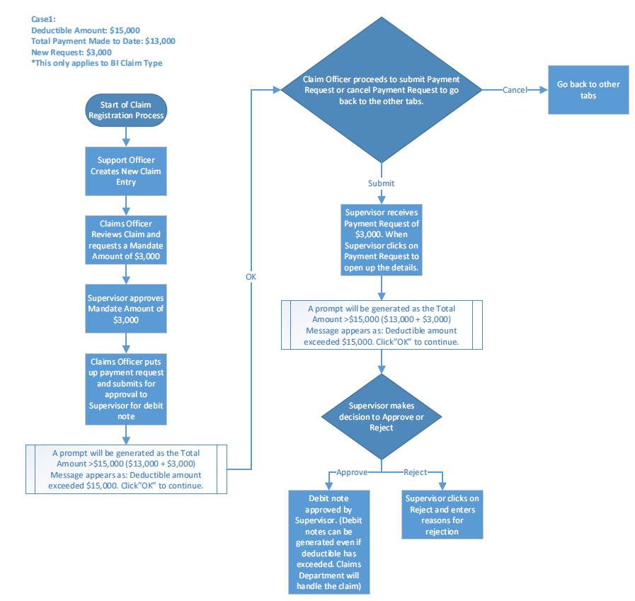

# Case 2

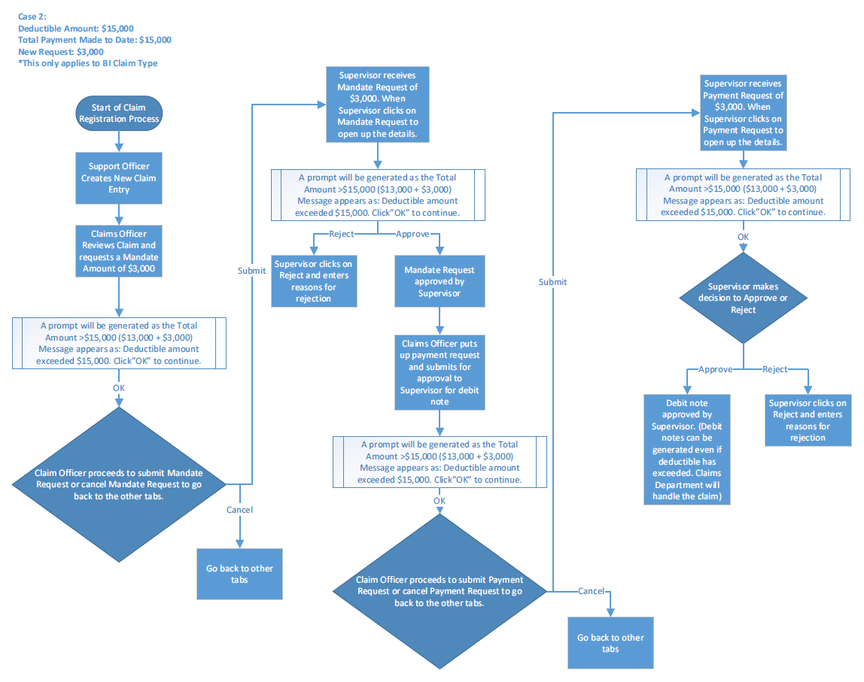

# Rule

|  |  |  |  |  |
| --- | --- | --- | --- | --- |
| **IF** | **Then** | **Else** | **And** | **Or** |
|  |  |  |  |  |
|  |  |  |  |  |

# Implementation

## Current Implementation

* Deductible Alert Indicator does not exist in application

## Targeted Implementation

* Deductible Alert Indicator Creation

# Change Required